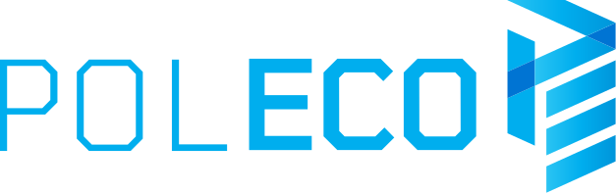

Press Release Poznań, 16.09.2021 r.

POLECO - time for real meetings
The waste management industry will face many challenges in the near future. It will be possible to discuss how to meet the growing requirements in terms of climate and environmental protection at the POLECO fair, which will be held on October 13-15.

Reducing the amount of waste generated, ensuring high-quality recycling and using recycled waste as an important source of raw materials - these are some of the solutions adopted by the government in the draft amendment to the act
about waste. The past year also saw several other significant changes in Polish legislation, such as the government program "Polish Deal" or "Poland's energy policy until 2040". - How will these legislative changes affect investments in local governments, enterprises or municipal economy? We will seek the answers together with the exhibitors and visitors of the POLECO fair, says Paulina Pietrzak, director of the POLECO International Environmental Protection Fair.

Innovation for the climate
The POLECO fair is a great place to discuss and exchange views on the most bothering topics in the climate and environmental protection sector, as well as to get to know with the latest technologies, products, services and solutions in the field of municipal technology, waste and recycling, air protection, water and sewage management and renewable energy sources.

POLECO is a presentation of solutions for local governments and enterprises from various industries. During this event, you can find effective solutions used in waste processing plants and sorting plants, waste container washers, ecological garbage trucks adapted to the collection and transport of new fractions of raw materials, as well as machines for maintaining greenery in cities and servicing public utility areas.

The POLECO fair is a meeting place for representatives of legislative institutions, local governments, representatives of the world of business, science and education directly related to the industry of climate and environmental protection, municipal management and sustainable development.

Product in circulation
For five years, POLECO has been accompanied by an exhibition of products and projects of the finalists of the PRODUCT IN CIRCULATION competition. The aim of this prestigious competition of the Minister of Climate and Environment is to promote and disseminate achievements in the field of ecological, sustainable design and the use of innovative solutions in the field of product recycle. The competition is intended for producers, designers, distributors, service providers and startups.

Projects can be submitted to the competition that fit into the circular economy, i.e. the idea of ​​minimizing the environmental impact of manufactured products by designing them and selecting materials that will enable their reuse. The competition is free. The deadline for applications is September 23, 2021. The competition is financed by the National Fund for Environmental Protection
and Water Management.

A celebration of Polish ecology
An integral part of the POLECO fair is the "EkoSfera" conference, which will be held this year in a hybrid formula on October 13. - This joint initiative of the Ministry of Climate
and the Environment and the National Fund for Environmental Protection and Water Management will be the venue for debates and talks on most of the current challenges facing Poland. The broad subject of the conference will cover issues related, among others, to the Polish Government, a strategic program, the implementation of which will allow us to ensure a future for us, our children and grandchildren, announces Michał Kurtyka, Minister of Climate and Environment. Famous speakers will also touch on related topics
with counteracting drought, eco-design, as well as the role of local governments in the context of climate change. It will be possible to participate in the conference thanks to the broadcast on www.poleco.pl and in social media.

The POLECO International Environmental Protection Fair will be held on October 13-15. A free ticket for professionals can be downloaded at www.poleco.pl

